**How to create your favorite domain**

Step 1: Open your web browser and enter url same below:

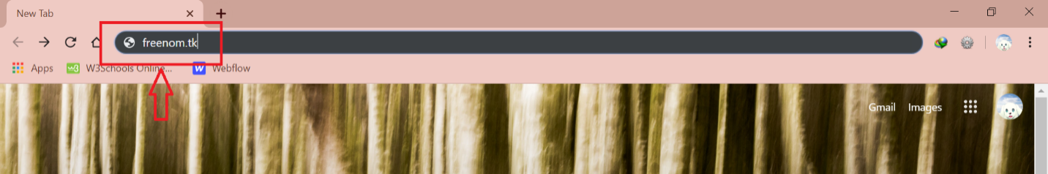

In this step, you enter “freenom.tk” to go to the signup new available domain.

Step 2: You enter your favorite domain in textbox and then click “Kiểm tra miền hiện còn” or press Enter.

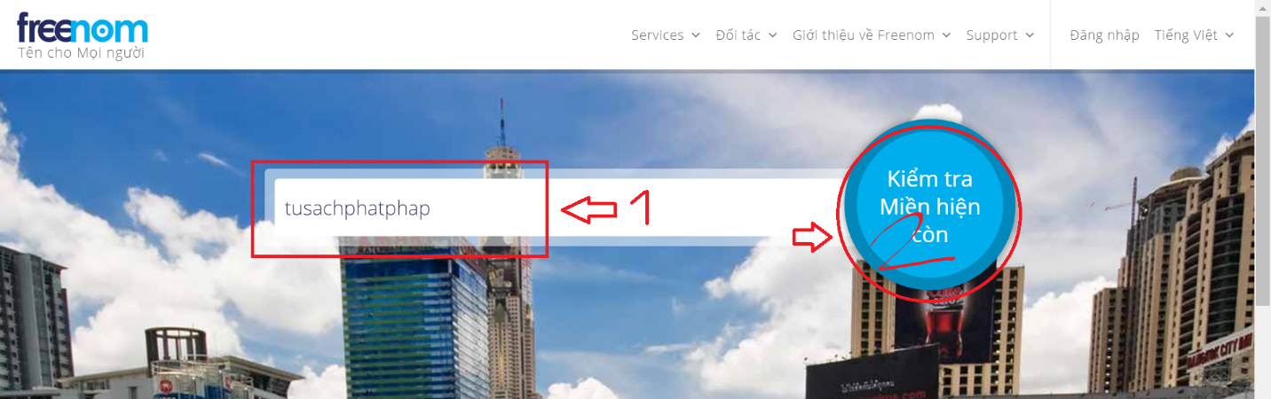

Step 3: Example you like .tk extension, on the right of the url, click “Nhận ngay!”.

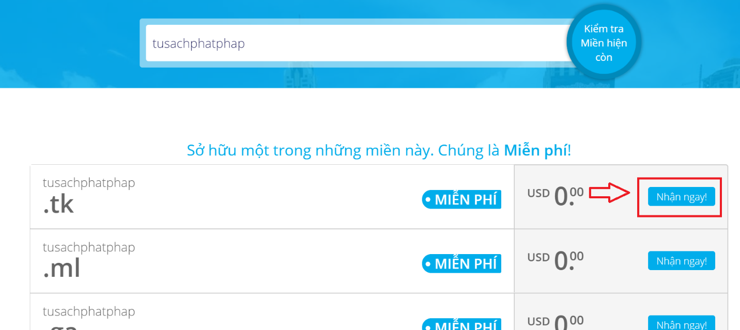

Step 4: Click “Thanh toán”.

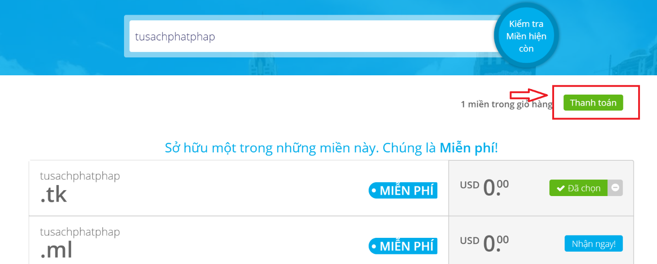

Step 5: On tab Preiod, you choose the time that you can use, the time that you don’t need pay money is under 12 months, after time use, if you want to use domain again, you must pay extra money.

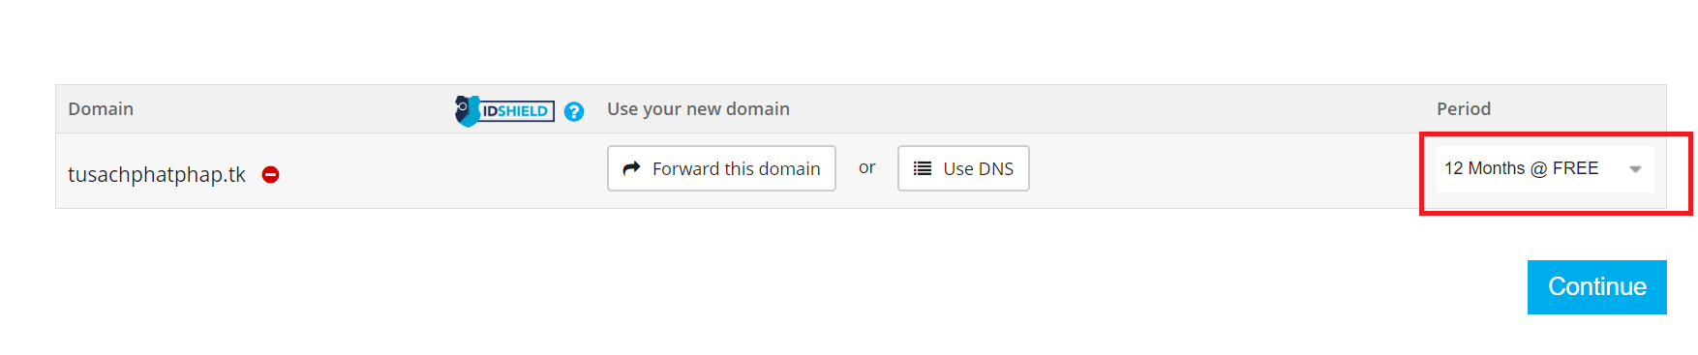

You can set the IP of the host that you want to go, by click “Use DNS”.

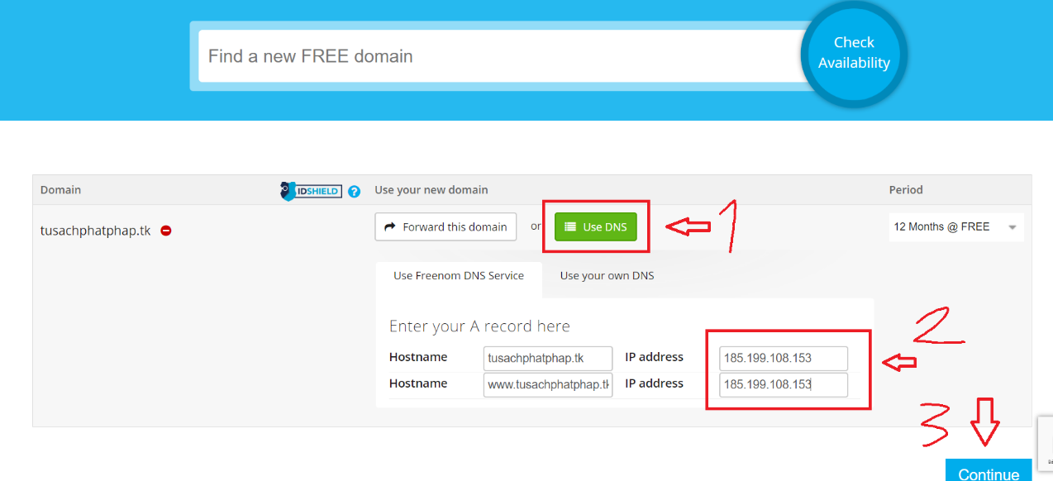

The step second on pic, you enter the IP address of the host. Above, the IP is the Github, and then click “Continue”.

Step 6: If you have a Google account or Facebook, you click A same below, if not, you enter the email address in the step 1 on pic, and then click “Vertify My Email Address”.

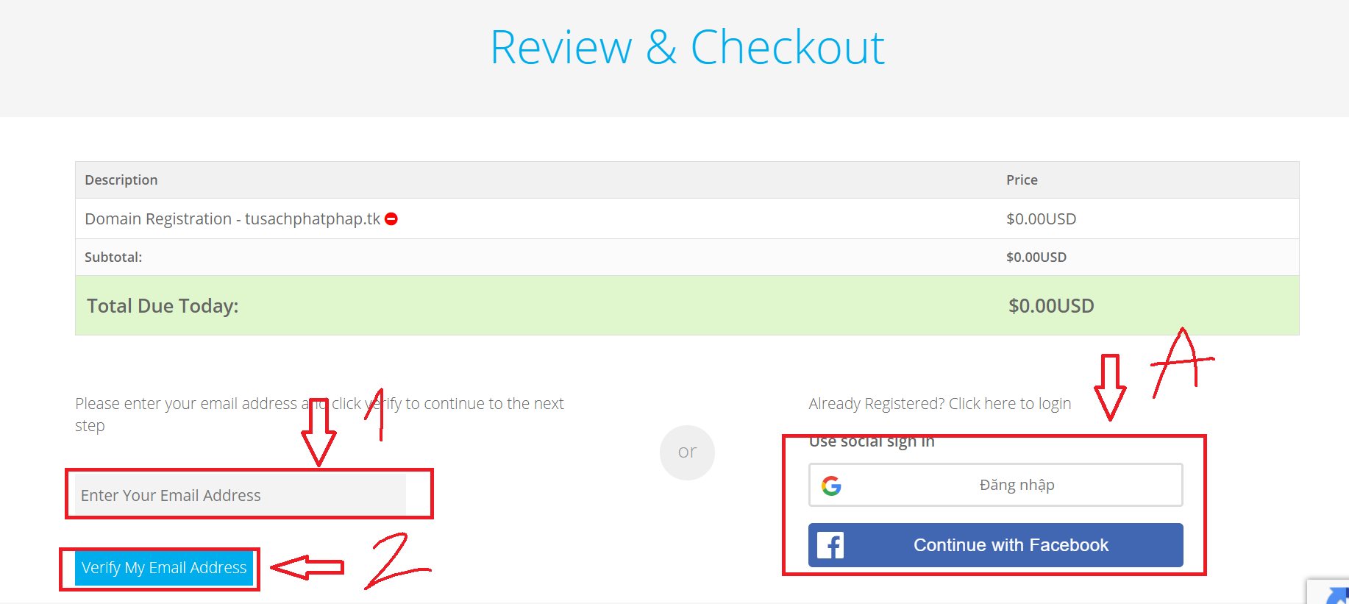

Step 7: After that, go to the email that you entered to vertify.

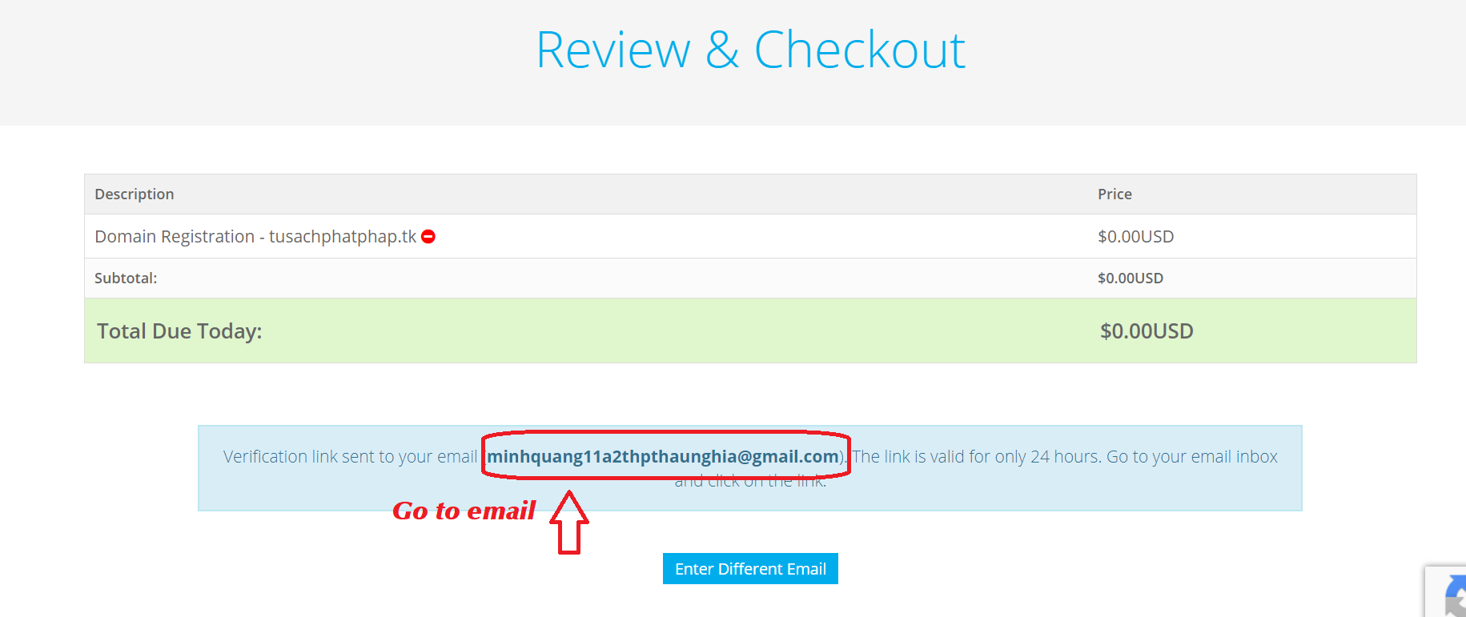

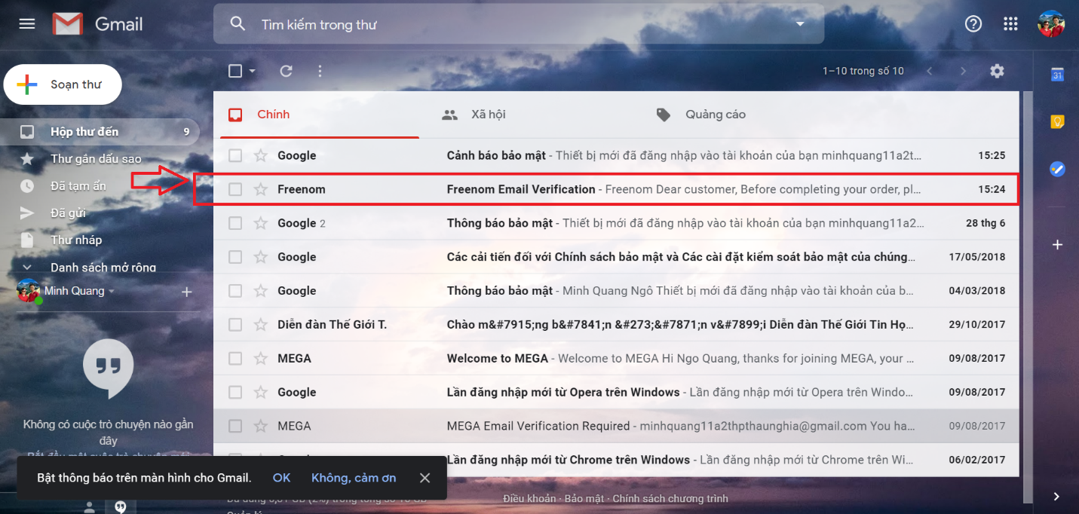

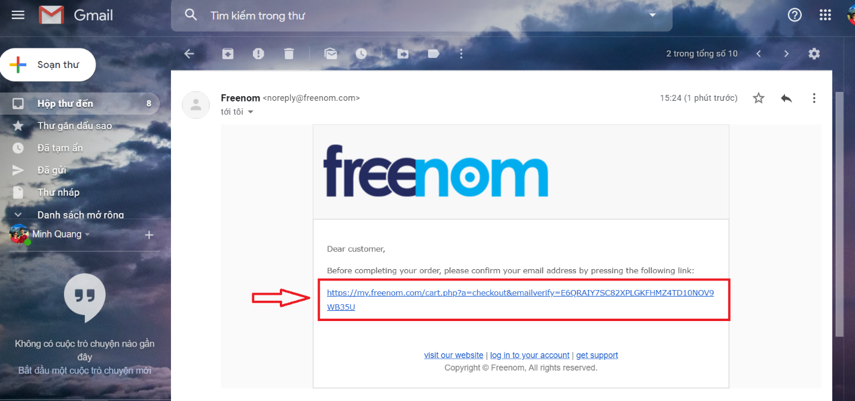

Step 8: After you vertifyed, you enter your informations, and then check box “I have read and argee to the Terms & Conditions”, press Enter or click “Complete Order”.

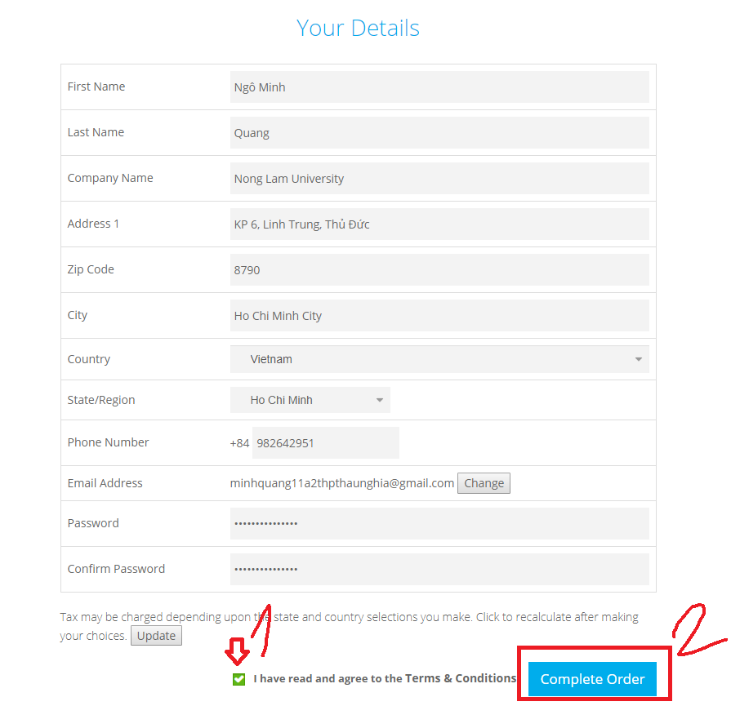

Step 9: On the sidebar, you click the menu “Services” -> My Domain to test your domain.

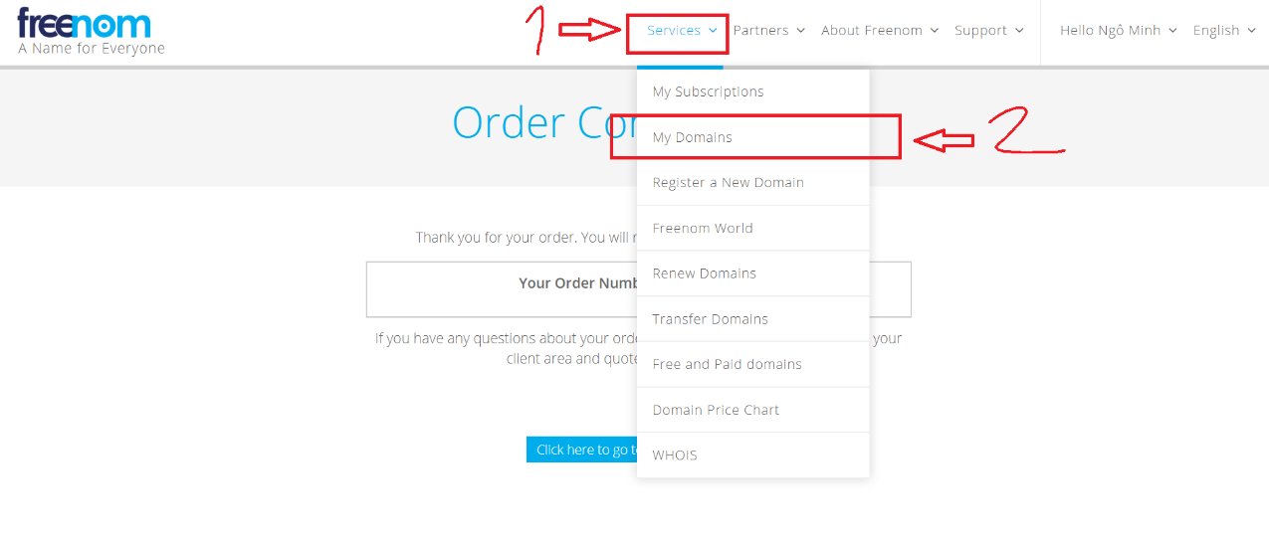

Step 10: If you go to the “My domain” page sucessfully, you can go to step 12, if not, you enter your account Freenom that you created (or you sign in by your Google account or Facebook account that you had) same below.

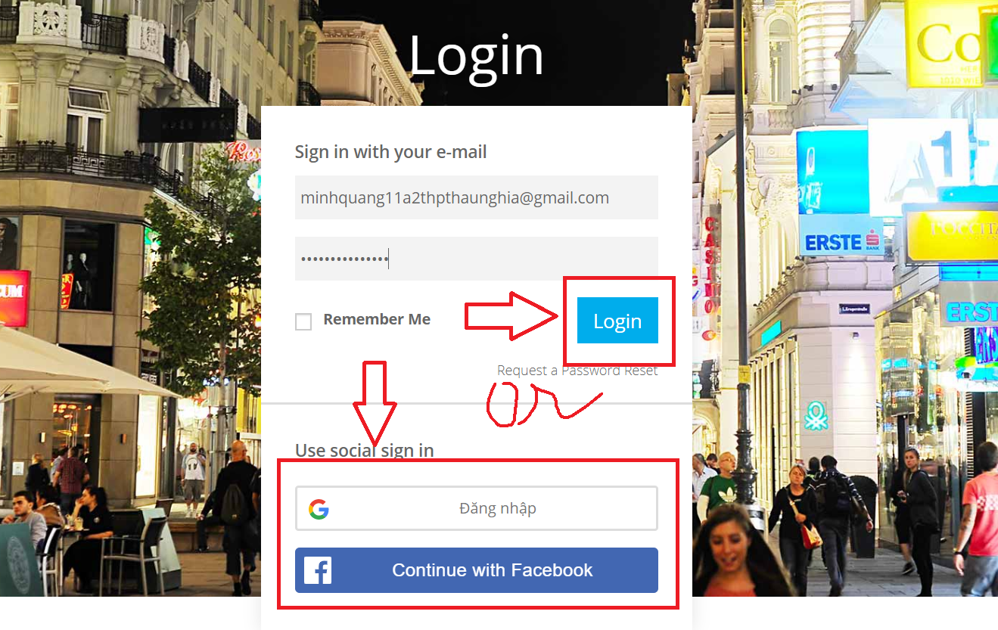

Step 11: Do same below

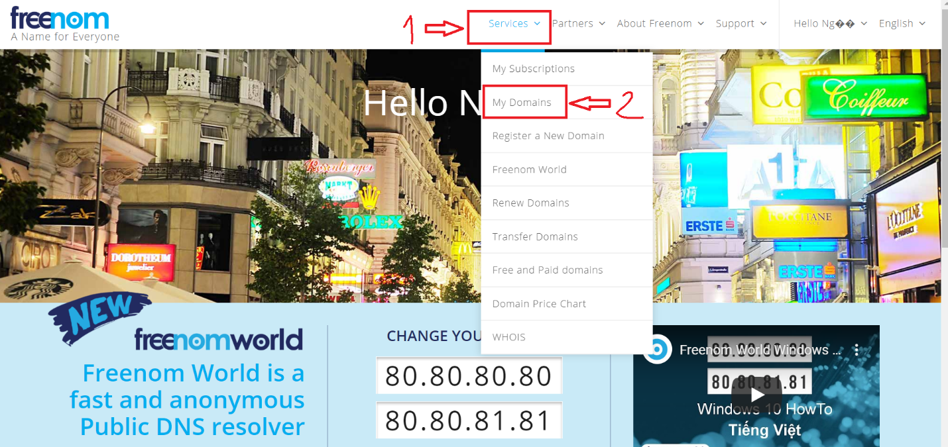

Step 12 (Finished):

In this pic, you see the important informations of your domain that you created, especially, in the Status, if you see the green text “Active”, this url can be accessed.

In addition, you can click “Manage Domain” to set your IP address if you change the host.

